**iLearnCentral: A CLOUD-BASED LEARNING CENTER**

**PLATFORM WITH MOBILE TECHNOLOGY**

A Research/Capstone Proposal

Presented to the Faculty of the

College of Computer Studies, University of Cebu

In Partial Fulfillment of the Requirements

for the degree Bachelor of Science in Information Technology

By

Jephunneh C. Mabini

Rhea Shane M. Chiong

Cristian G. Paragoso

Mr. Edsel C. Paray

Adviser

October 2019

1. **ACKNOWLEDGMENT**

The completion of this study would not have been possible without the presence of the following:

First and foremost, we offer our warm gratitude to our Adviser, Engr. Edsel C. Paray, for sharing his knowledge and guidance in writing our manuscript, for being patient in checking our papers, and for giving suggestions and inspiration for the study’s completion.

To our dear parents, we offer our warm gratitude for the prayers, love, concern, and financial support.

To those who are not mentioned but, in one way or another, have helped us in this study, the product of this manuscript would not be possible without all of them.

Above all, the Almighty Father, the source of infinite wisdom, strength, and goodness. To God be the glory!

**The Researchers**

Jephunneh C. Mabini

Rhea Shane M. Chiong

Cristian G. Paragoso

**DEDICATION**

This project is lovingly dedicated to our respective parents, who have been our constant source of inspiration. They have given us the drive and discipline to tackle a task with enthusiasm and determination. Without their love and support, this project would not have been possible.

To our advisers and professors who genuinely helped us to finish this work,

And above all,

To our beloved God Almighty who never surrendered to shed us His love, grace and wisdom to accomplish this study that, somehow in the very near future, may contribute to help those who will use and appreciate it.

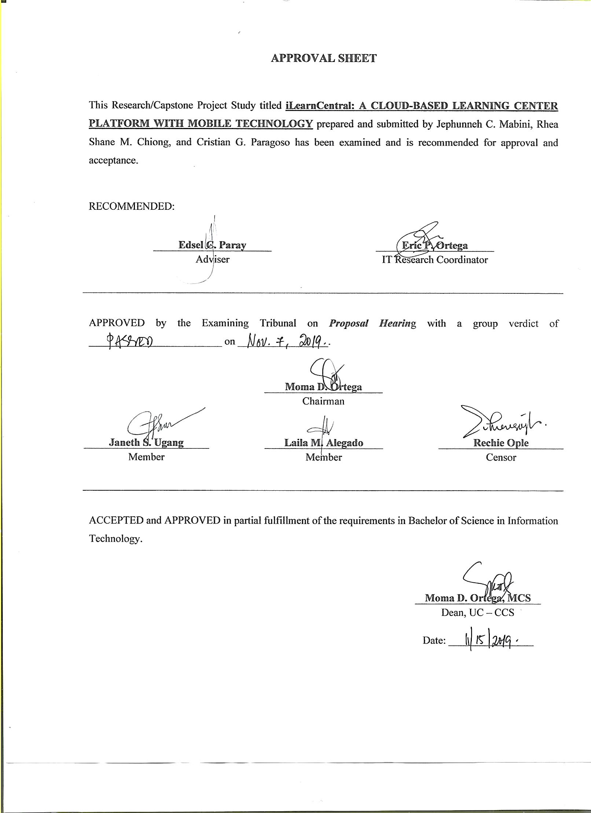

**TABLE OF CONTENTS**

**Page**

ACKNOWLEDGMENT ..................................................................................... ii

DEDICATION .................................................................................................. iii

APPROVAL SHEET ..................................................................................... iv

TABLE OF CONTENTS ..................................................................................... v

LIST OF TABLES .................................................................................................. vii

LIST OF FIGURES .................................................................................................. viii

CHAPTER I: INTRODUCTION

Rationale of the Study ..................................................................................... 1

Objective of the Study ..................................................................................... 2

Scope and Limitations ..................................................................................... 2

Significance of the Study ........................................................................ 3

Flow of the Study ..................................................................................... 4

Definition of Terms ..................................................................................... 5

CHAPTER II: REVIEW OF RELATED LITERATURE AND STUDIES

Related Literatures ..................................................................................... 6

Related Studies ..................................................................................... 9

Comparative Matrix ........................................................................ 10

CHAPTER III: RESEARCH METHODOLOGY

Software Engineering Methodology ........................................................... 12

Planning/Conception-Initiation Phase ........................................................... 14

Business Model Canvas ........................................................... 15

Program Workflow ......................................................................... 16

Validation Board ......................................................................... 19

Gantt Chart ...................................................................................... 19

Functional Decomposition Diagram ............................................... 22

Analysis-Design Phase ............................................................................ 22

Use Case Diagram ......................................................................... 23

Storyboard ...................................................................................... 24

User Interface Diagram ................................................................... 25

Database Design ......................................................................... 34

Entity-Relationship Diagram ............................................... 43

Data Dictionary ............................................................... 44

Network Design

Network Model ......................................................................... 52

Network Topology ......................................................................... 52

Development/Construction/Build Phase .................................................... 53

Technology Stack Diagram ............................................................ 53

Software Specification ....................................................... 55

Program Specification ................................................................... 56

REFERENCES ................................................................................................... 58

CURRICULUM VITAE ...................................................................................... 60

APPENDICES

A – Working Title Form *.........................................................................*  63

B – Consultation Log Form *.........................................................................*  64

C – Censor’s Certificate *.........................................................................*  65

**LIST OF TABLES**

Table No. Table Name Page

1 Comparative Matrix 10

2 Business Model Canvas 15

3 Validation Board 19

4 Gantt Chart 20

5 User Document 35

6 Learning Center Document 35

7 Educator Document 36

8 Resume Document 37

9 Student Document 38

10 Job Vacancy Document 39

11 Job Application Document 39

12 Course Document 40

13 Enrolment Document 40

14 Payment Document 40

15 Classes Session Document 41

16 Schedule Request Document 41

17 Lesson Plan Document 42

18 Student Record Document 42

19 Database Data Dictionary 44

20 Software List of Modules 56

**LIST OF FIGURES**

Figure No. Figure Name Page

1 Flow of the Study 4

2 Agile Development Methodology 12

3 User Activity Program Workflow 16

4 Hiring Module Program Workflow 17

5 Enrolment Module Program Workflow 17

6 Scheduling Module Program Workflow 18

7 Teaching Assistance Module Program Workflow 18

8 Functional Decomposition Diagram 22

9 Use Case Diagram 23

10 iLearnCentral Storyboard 24

11 Login Page 25

12 Account Type Selection Page 26

13 Sign up Page 26

14 Feature Subscription Page 27

15 Learning Center Profile Page 28

16 Job Posting Page 28

17 Applicants List Page 29

18 Potential Hire Search Page 29

19 Class Management Page 30

20 Educator’s Profile Page 30

21 Job Search Page 31

22 Learning Center Search Page 31

23 Activity Management Page 32

24 Student/Parent Profile Page 32

25 Class Browsing Page 33

26 Enrolment Page 33

27 Payment Scheme Page 34

28 Entity Relationship Diagram 43

29 Network Model 52

30 Network Topology 52

31 Technology Stack Diagram 53